**Thank**



**Keeping In Touch**

Thank you so much for all the amazing photos and feedback we have already received. We’ve absolutely loved seeing what you’ve been up to at home.

From today your child’s class teacher will be available on the e-mails down the side of this newsletter.

Teachers will be able to answer any questions and queries you have about your child’s work or learning progress. Feel free to send them any questions. You can also send them pictures or attachments of your child’s work, if you would like feedback or you have some super learning to celebrate. Teachers will respond between the hours of 9.00 a.m. and 3.00 p.m. Monday to Friday, during term time. Although they will attempt to respond as soon as possible within these hours, please be patient as they are also on a rota to support Key Worker’s children in school.

Here are some lovely examples of photos we’ve been sent so far:

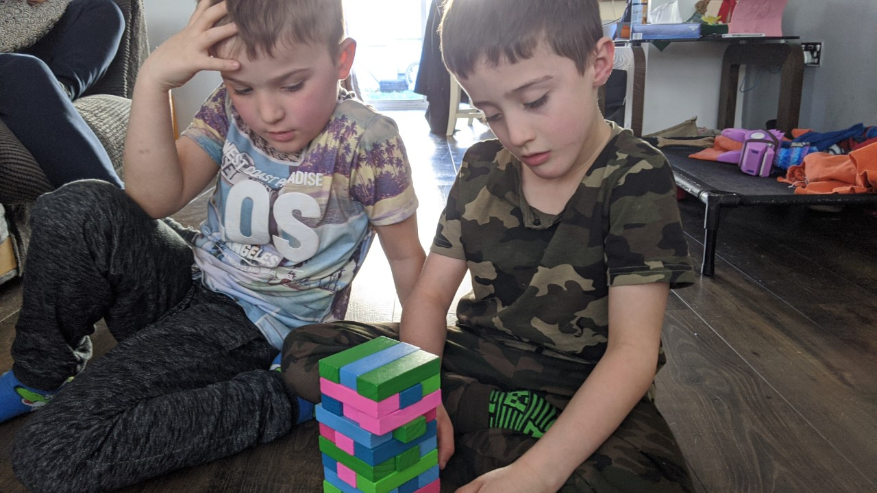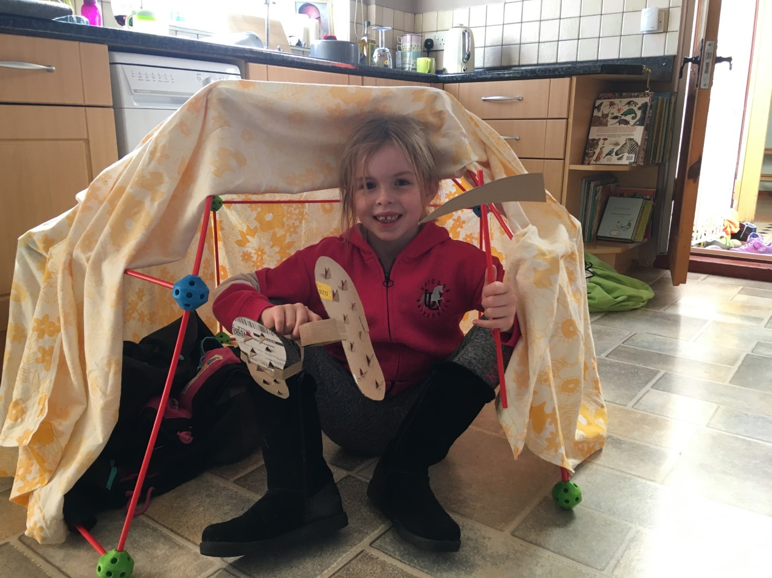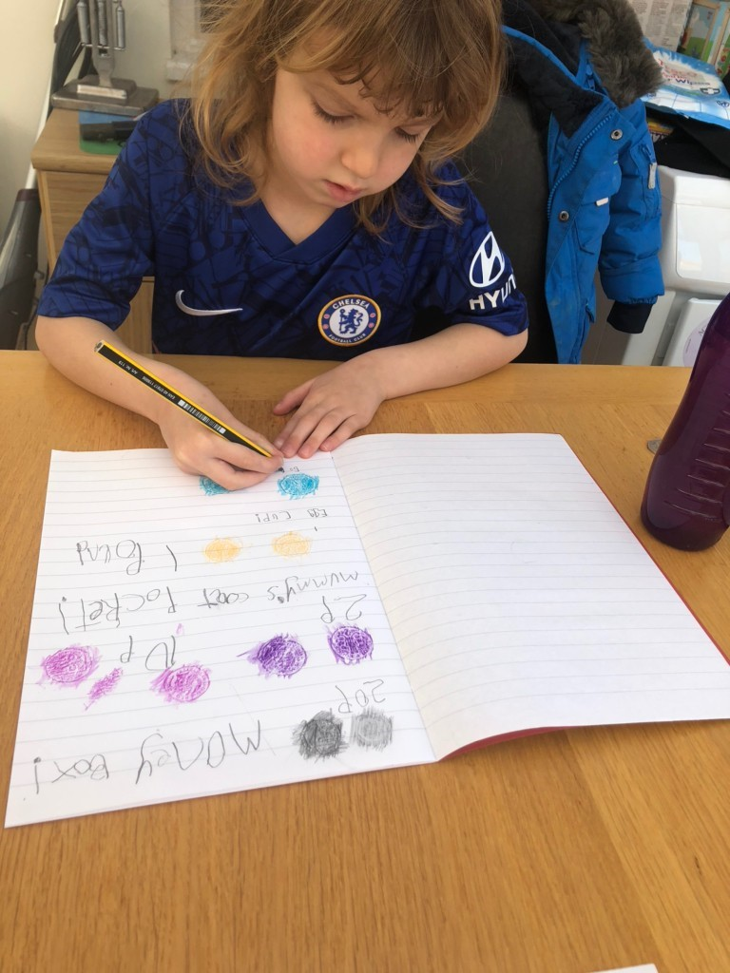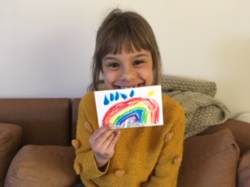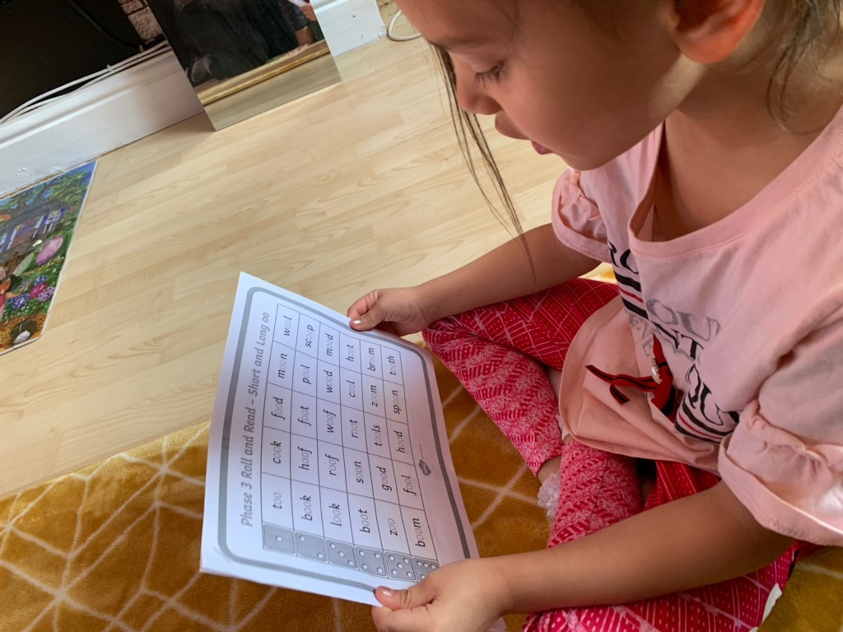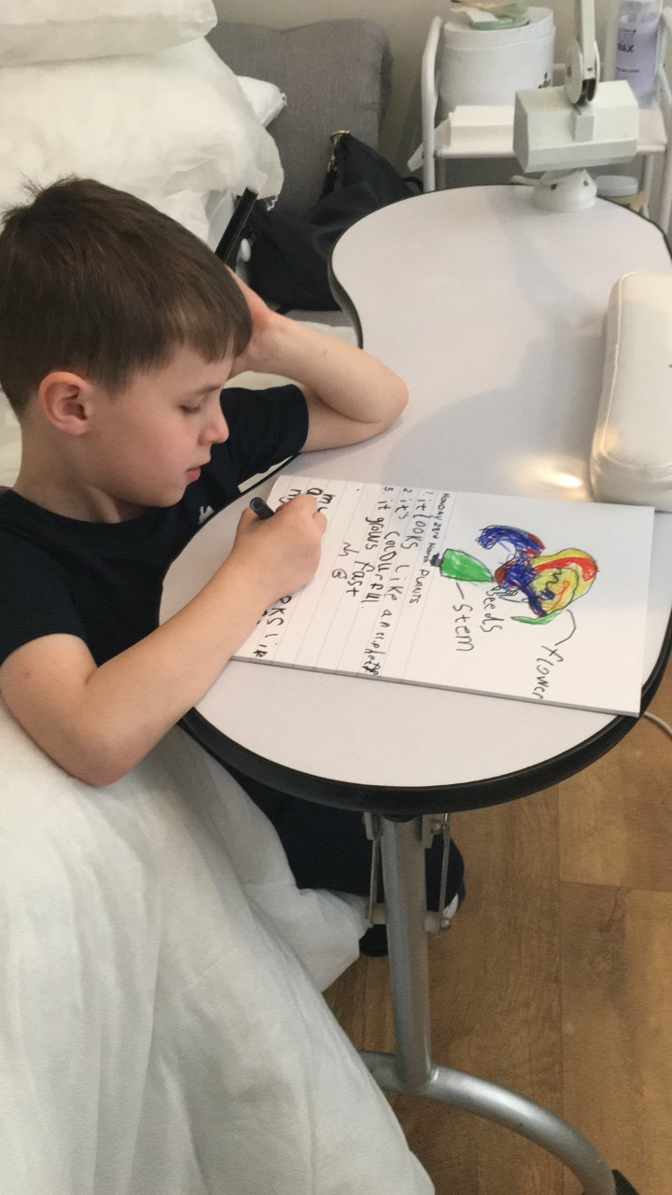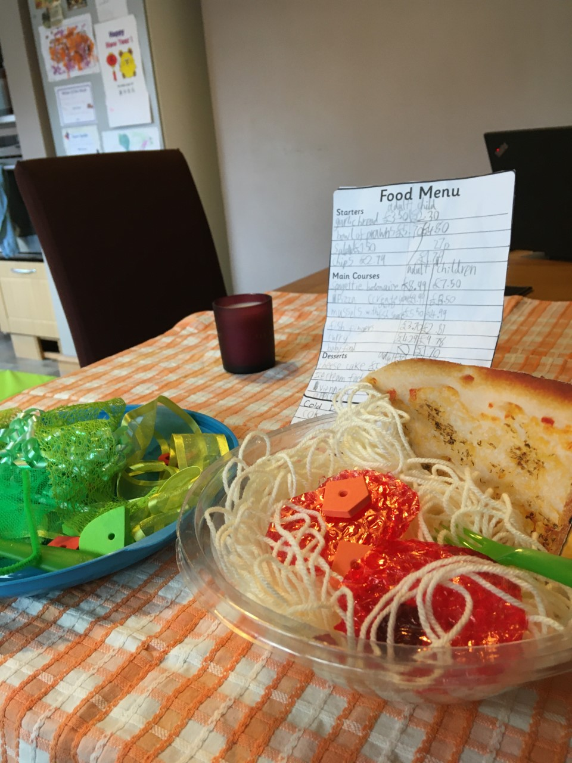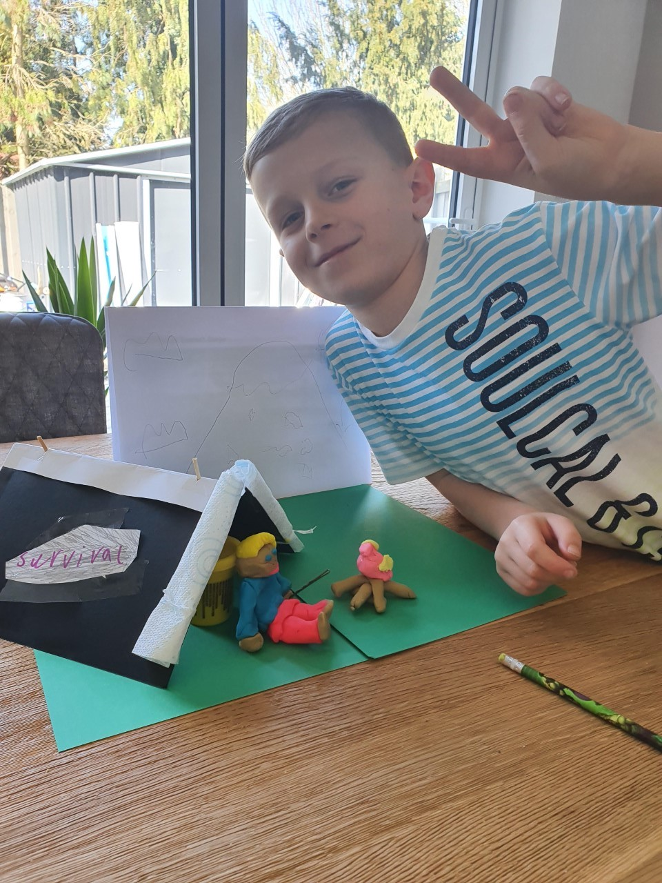

Miss Roulston: [foundationcircles@st-lawrence-pri.essex.sch.uk](mailto:foundationcircles@st-lawrence-pri.essex.sch.uk) Miss Pryce: [foundationsquares@st-lawrence-pri.essex.sch.uk](mailto:foundationsquares@st-lawrence-pri.essex.sch.uk)

Ms Rayner and Mrs Musson:

[year1@st-lawrence-pri.essex.sch.uk](mailto:year1@st-lawrence-pri.essex.sch.uk)

Mrs Auton and Mrs Frost: [year2@st-lawrence-pri.essex.sch.uk](mailto:year2@st-lawrence-pri.essex.sch.uk)

Mrs Parker:

[year3@st-lawrence-pri.essex.sch.uk](mailto:year3@st-lawrence-pri.essex.sch.uk)

Mrs Alexander:

[Year4@st-lawrence-pri.essex.sch.uk](mailto:Year4@st-lawrence-pri.essex.sch.uk)

Mrs Aylett:

[Year5@st-lawrence-pri.essex.sch.uk](mailto:Year5@st-lawrence-pri.essex.sch.uk)

Miss Birbeck:

[Year6@st-lawrence-pri.essex.sch.uk](mailto:Year6@st-lawrence-pri.essex.sch.uk)

[](https://www.google.co.uk/url?sa=i&rct=j&q=&esrc=s&source=images&cd=&cad=rja&uact=8&ved=0ahUKEwjoz7frmPjOAhWCshQKHeSbBuQQjRwIBw&url=https://www.tumblr.com/tagged/thunk-show&bvm=bv.131783435,d.ZGg&psig=AFQjCNHHKuvwcVPYRzhGqnFNpzuLAAf9UQ&ust=1473163726646017)

**Why is colour important?**

**Headteacher Awards**

Bobby in Red Circles; Zachary, Brooke, Gabbie and Evie J in Red Squares; Jake and Ivy in Year 1; Evie in Year 2; Hayden, Jack, Cleo, Eliza, Elijah and Noah in Year 3; Riley in Year 5; Alex, Archie and Emily in Year 6

**Winning KS1 Answer by Oscar J in Red Squares**

*If you didn’t have colour you wouldn’t see anything*

**Winning KS2 Answer by Eliza in Year 3**

*A world without colour is a world without love, because I think love is colourful like a rainbow in spring*

**Home Learning**

We hope you are finding our home learning useful. Please do not feel under pressure to complete it all, you must find the right balance. For some families home learning resources will be very helpful but for others it might feel like too much to cope with. If your child likes to play in the garden, bake, play board games, make art, chat; these are all important learning exercises too.

Remember that there is always a member of staff at school, including a safeguarding lead. Ring the office or send us an email if you would appreciate a chat, or email your class teacher if you would like to discuss home learning. We’re all here to support you.

**Concerns**

If you are worried about a family who seems isolated and unable to communicate with school then please let us know. It will be completely anonymous and we will reach out to offer and provide any support we can.

**Rainbows**

You have created the most AMAZING rainbow work from our topic this week! We’ve seen poems, postcards for grandparents, prayers, scientific research, creative ICT skills, PowerPoint presentations, and lots and lots of AMAZING ART. How many rainbows have you spotted in windows around the village and beyond? What a fantastic way to show that even though we are not physically together, we’re still a resilient, loving, and hopeful community. Here are just some examples of the inspirational art we’ve seen:

